Using Turnitin.com
Institutional Account for Bellevue College
February 2011
Library Media Center

Faculty need | Students need
First name | First name
Last name | Last name
Email address | Email address
Password to join account as an instructor | Class name
 | Class code
 | Class password

Go to TURNITIN.COM
Students can be reminded that there are laptops available for them to borrow for use on campus. They need to go to the Library Media Center.

Enrolling in a Class – For Students
Students must enroll in a class before they can begin using Turnitin. In order to enroll in a class the student must have the class id and enrollment password which can only be distributed by the class instructor. Students can enroll in multiple classes from the same user profile.
Instructor must make sure there is only one entry per student.
How to create a new user profile and enroll in a class
- Click the "Create Account" link to the left of the Sign in button on the Turnitin homepage
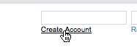
- Click on the student link from the Create a New Turnitin Account screen
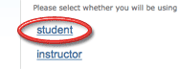
- Enter your class id and enrollment password in the appropriate fields
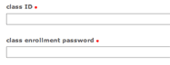
- Enter your first name, your last name, and the e-mail address you would like associated with your Turnitin account (this will be your user name)
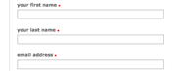
- Enter (and re-enter) the password you would like to use as your Turnitin login password
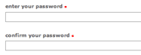
- Select a secret question using the secret question pull down menu, enter an answer
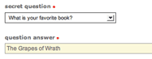
- Review the Turnitin user agreement and click to agree and finalize user profile creation<
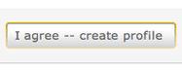

Submitting Papers as a Student
Only instructors and students can submit papers to classes in Turnitin. Students can submit papers through either the file upload or cut and paste method.
If the student has the file he or she would like to submit in an accepted file format on his or her computer, he or she can use the single file upload method.
How to use the single file upload submission method
- Click on the class name
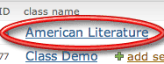
- Click on the Submit button to the right of the assignment name
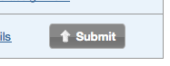
- Select "single file upload" from the "choose a paper submission method:" pull down menu
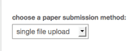
- Enter the paper title for the submission in the appropriate field. Title is required.
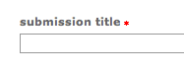
- If your instructor has provided you with the option to select which repository you would like your paper stored in the "add to" option will appear within the submission screen. There are two options: either to add your paper to the standard paper repository or to the institution paper repository. Select which repository you would like your paper added to
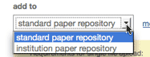

- Click browse to find the file on your computer
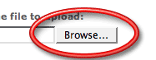
- Find the file on your computer and click open
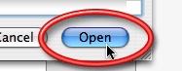

- Click upload
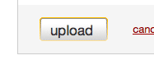
- Review the file and click on the "Submit" button to finalize the submission
Student should make sure that they receive the message “…submission successful…”
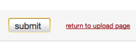
If the student would like to submit only a section of text from a file, only has the file in an unaccepted file type or only has a hard copy of the paper he or she would like to submit, the student should use the cut and paste method of submission.
How to use the cut and paste method of submission as a student
- Click on the class name
- Click on the Submit button to the right of the assignment name
- Select "cut & paste" from the "choose a paper submission method:" pull down menu
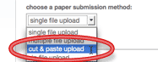
- Enter the paper title for the submission in the appropriate field
- Either select the text you would like to submit from the source file on your computer, or type the text you would like to submit in the large "cut and paste" field
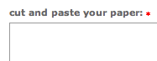
- If your instructor has provided you with the option to select which repository you would like your paper stored in the "add to" option will appear within the submission screen. There are two options: either to add your paper to the standard paper repository or to the institution paper repository. Select which repository you would like your paper added to
- Click submit to finalize the submission
Additional Information
- The file size may not exceed 20 MB. Files of larger size may be reduced in size by removal of non-text content. Files that are password protected, encrypted, hidden, system files, or read only files cannot be uploaded or submitted to Turnitin.
- Text only files may not exceed 2 MB.
- Students will receive a digital receipt containing a paper id both on screen and in e-mail for every successful submission. If the student does not receive a digital receipt for a submission, the submission was not successful.
- In the file upload method of submission step 9 is critical. If the student does not click the final "submit" the file will not be submitted.
- Turnitin currently accepts the following file types for submission: MS Word (.doc), WordPerfect (.wpd), PostScript (.eps), Portable Document Format (.pdf), HTML (.htm), Rich Text (.rtf) and Plain Text (.txt). All files submitted to Turnitin must be text based. Papers which have been scanned must be sent through Optical Character Recognition (OCR) software before they can be submitted to Turnitin.
- Turnitin will automatically exclude papers submitted to the class under the same author's name from the Originality Report for a paper. This automatic exclusion is based first on the author's e-mail address then on the author's name. This means even if the authors of two papers in the class have the same name (i.e. John Doe and John Doe) the system will not exclude the papers from one another's Originality Reports if different e-mail addresses are used ( i.e. JDoe@turnitin.com and JDoe@iparadigms.com).
- Only one file per student can exist for each assignment. Students who would like to submit multiple papers will need to either submit to multiple assignments or combine the papers into one file for submission.

