NUTR100 FENSTER FINAL Integrating Sustainability Fall 2013
Statement connecting sustainability to your discipline
Regarding Nutrition and Sustainability; I see students first needing to learn about the linear system of extraction, production, distribution, consumption and disposal. I then see students working in groups to identify "points of insertion" and area's for change/solution. I would like students to research examples of fair trade food goods, closed loop farming practices and local living economies and then present on their findings in front of the class.
Other links between sustainability and nutrition:
- Differentiating between hunger and appetite and their link to obesity prevention or a cause of obesity. Eating solely based on appetite may drive the linear system of extraction, production, distribution, consumption and disposal of cheap, poor nutrient quality food.
- Recognizing all the systems that keep food insecurity rampant are also area's that keep the linear model working; i.e.; poverty, class structures, social inequalities, farming subsidies that continue production of cheap Calories instead of nutrient dense Calories.
- Calculating the "externalized costs" of eating animal protein vs. plant sources of protein

Teaching Strategies
My teaching strategies are designed to get the students to recall their own relationship with hunger and food security, share that knowledge then research and write a paper about one cause of food insecurity and solutions to prevent it.
All the methods I will be using include: class lecture, an in-class brainstorming activity with homework questions, watching a Ted Talk and a documentary, and having my students write a paper about a solution to prevent food insecurity.
Teaching Portfolio
Beginning Week 7 I introduce Food security, Food insecurity and Nutritional Deficiencies to reinforce the importance of nutrients and their role in health (vitamins, minerals, water, carbohydrates, lipids, and protein). To begin the students will participate in an in-class activity: Exploring food insecurity and malnutrition. (shown below)

In-Class Activity Exploring Food Insecurity and Malnutrition (Lesson Plan)
In-Class Activity splits into groups of three (large group’s 10-12 people per group), each round takes 10 minutes, four rounds, requires lots of post it notes, 3 dry erase markers and three white boards.
Nutrition 100 Learning Outcome: Recognize local and global hunger, and how they can impact hunger in our world.
Sustainability Outcome: Apply an ethical perspective in which one views oneself as embedded in the fabric of an interconnected world.

Round 1- each group works to define their term and brainstorm on post-it notes (10 minutes)
Group A
- Look up the term “food security” in text book glossary and read it.
- Assign one group member to write the definition large and clearly on the white board.
  - Access by all people at all times to enough food for an active and healthy life. Food security has two aspects: ensuring that adequate food supplies are available and ensuring that households whose members suffer from undernutrition have the ability to acquire food, either by producing it themselves or by being able to purchase it.
- Begin brainstorming (one idea/example per post-it) reasons why you are or have felt food secure, aim for two examples/ideas per person.
- Hint if stuck…Think of all five stages of food production; reflect on all the systems in place that allow food security in the United States.
- Apply post-its below definition

Group B
- Look up the term “food insecurity” in text book glossary and read it.
- Assign one group member to write the definition large and clearly on the white board.
  - The inability to acquire or consume an adequate quality or sufficient quantity of food in socially acceptable ways or the uncertainty that one will be able to do so.
- Begin brainstorming (one idea/example per post it) reasons why you are or have felt food insecure
- Hint if stuck…Think of all five stages of food production, reflect about how interference at one or more stages could lead to food insecurity
- Apply post-its below definition

Group C
- Look up the term “malnutrition” in text book glossary and read it.
- Assign one group member to write the definition large and clearly on the white board.
  - The impairment of health resulting from a relative deficiency or excess of food energy and specific nutrients necessary for health.
- Begin brainstorming (one idea/example per post it) physical symptoms or names of diseases that are linked to malnutrition, aim for 1-2 examples per person
- Hint if stuck…if you were unable to eat citrus fruits or fresh vegetables all winter long what nutrient would you be missing and what symptoms would begin showing in your gums/mouth?
- Apply post-its below definition

Round 2- groups rotate clockwise to a different term (10 minutes)
- Each person reads term, definition and post-its
- Add additional content/brainstorming
Round 3- groups rotate clockwise one last time (10 minutes)
- Each person reads term, definition and post-its
- As a group, begin organizing the information into categories, use dry erase markers to label/title your categories. (Examples of categories from previous classes… National and International; Least and Greatest; Deadly to Least Deadly; Water soluble to Fat soluble; etc.)
Round 4- reporting and reasoning (3 minutes each group)
- Each group reports on how and why they chose to organize/categorize the post-it note information
- Share most significant/important examples
(End of lesson plan)
After completing In-class activity Exploring Food Insecurity and Malnutrition students will complete homework reflection questions (worth 5 points). This will serve as a formative assessment. Nutrition 100 Learning Outcome: Recognize local and global hunger, and how they can impact hunger in our world.
Which populations of individuals are most likely experiencing food security. Why?
- Who is most likely food insecure? Why?
- Who is most at risk to becoming malnourished?
- What nutrients are most likely to be deficient, why?
- Recall your diet analysis assignment and what nutrients were under-status; did food insecurity have any connection? Explain why or why not?

Also during Week 7, students will watch a Ted talk: The Global Food Waste Scandal by Tristram Stuart. These first two activities will serve as introductory pieces linking food insecurity to sustainability issues.
- http://www.ted.com/talks/tristram_stuart_the_global_food_waste_scandal.html
- Nutrition 100 Learning Outcome: Recognize local and global hunger, and how they can impact hunger in our world.
- Sustainability Outcome: Explain how sustainable thinking and decision-making contribute to solutions for current and emerging social, environmental and economic crises.

During Week 11, chapter which is Food Safety, Technology and Global Hunger
- In class lecture on The Food System model (Figure shown below)
- In class documentary
  - Joanes, A. (Director). 2009. Fresh [Documentary]. United States.
- Class discussion about sustainable vs. conventional farming practices, student complete assignment 9 (worth 10 points)
- Students turn in paper: Solutions to Food Insecurity (worth 10 points)

The Food System Model
Thompson, J., & Manore, M. (2013). Nutrition for Life 3rd Edition. Boston MA: Pearson Education.
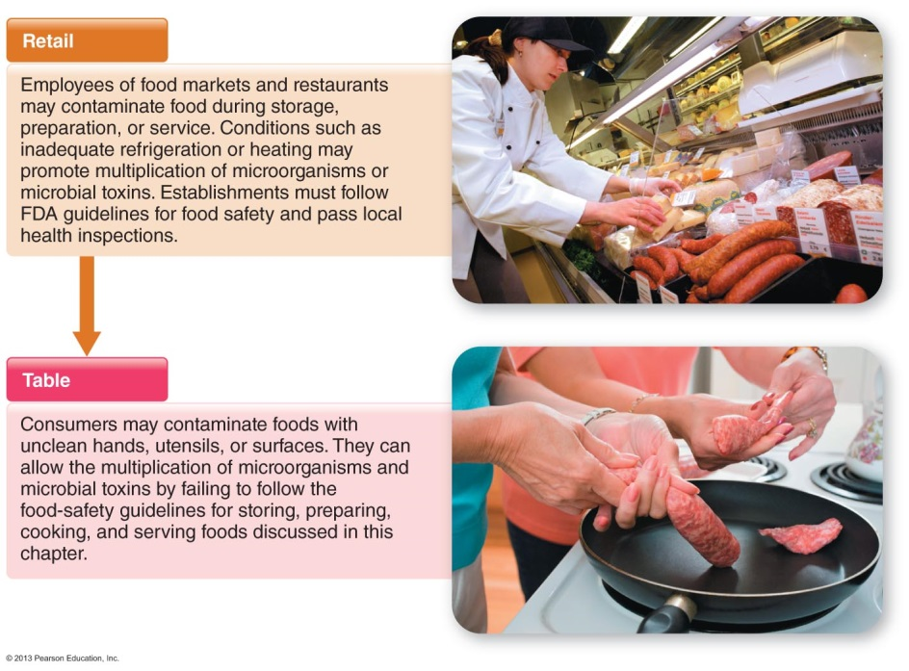
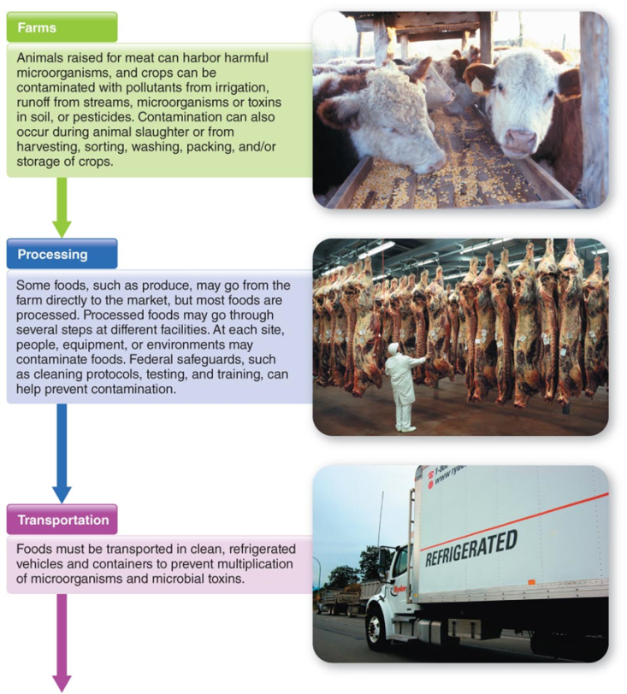

Assignment 9 Food Safety Score card and Video Questions (Worth 10 points)
Nutrition 100 Learning Outcome: Recognize local and global hunger, and how they can impact hunger in our world.
Sustainability Outcome: Apply an ethical perspective in which one views oneself as embedded in the fabric of an interconnected world. Explain how sustainable thinking and decision-making contribute to solutions for current and emerging social, environmental and economic crises.

Name ______________________________________________ Date ________________________
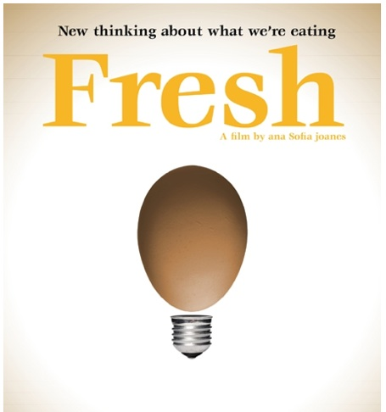
- After watching the movie Fresh, what does sustainable agriculture mean to you?

- Create a list of Pro’s and Cons associated with any conventional (industrial) food production and its impacts on the animal, public health and the environment.

Nutrition 100- Assignment 10 Solutions to Food Insecurity Paper Nutrition 100 Learning Outcome: Recognize local and global hunger, and how they can impact hunger in our world.
Sustainability Outcome: Apply an ethical perspective in which one views oneself as embedded in the fabric of an interconnected world. Apply practical solutions to real-world sustainability challenges.

Directions- Referring to Chapter 12 Nutritional Issues: The Safety and Security of the Worlds Food Supply; also p. 352, 397-400, p. 404
Write a 500-750 word essay:
- Paper must be submitted to me through Canvas, do not print this paper. Open inbox, To: Shannon Fenster, copy your entire paper and paste it into the message box in canvas, hit send.
- Identify one factor/cause that contributes to food insecurity (local or global). Describe what this factor is.
  - For example; a tsunami contributes to food insecurity. A tsunami is a series of water waves…
- Discuss how this factor/cause leads to hunger.
  - For example; Tsunami causes hunger by its massive destruction to homes, stores and agricultural land…
- Then propose a solution to prevent, reduce or eliminate this factor which causes food insecurity. Be thorough and creative with your solutions.
- Cite references in APA format.
- List word count at end of paper (do not include heading or bibliography in word count). Papers written outside of word count range will not receive full credit. Submit bibliography (references) at end of paper.

Directions on how to cite a reference in APA format are available at the library or on Bellevue College’s Website. See the: www.bellevuecollege.edu
- Click on Library (on bottom of main page site)
- Click on Research Help
- Click on New! APA Style Documentation, 6th edition

Nutrition 100 Learning Outcomes | Sustainability Outcomes
- Describe the role of scientific research associated with human nutrition.
- Explain the uses of the various dietary reference intakes (DRI) for human nutrition.
- Design a healthy diet in context with current scientific evidence and cultural health patterns.
- Explain the function of carbohydrates, lipids (fats) and proteins with respect to digestion, absorption and elimination in the human body.
- Describe the function of micronutrients (vitamins and minerals) in the human adult body.
- Explain the importance of diet and exercise for human health.
- Describe effects of culture and diet choices on nutrition and health.
- Critically evaluate food fads and diets based upon science data that support claims.
- Explain eating disorders and their health impacts.
- Recognize the importance and value of food safety.
- Recognize local and global hunger, and how they can impact hunger in our world. | 2. Apply an ethical perspective in which one views oneself as embedded in the fabric of an interconnected world.  5. Explain how sustainable thinking and decision-making contribute to solutions for current and emerging social, environmental and economic crises.  6. Apply practical solutions to real-world sustainability challenges.
- Conduct and evaluate a current nutritional status self-analysis.

Nutrition100 Personal Nutrition – Winter 2014 Section 3877A or Section 3870B
5 Credits
Instructor Name: Shannon Fenster
E-mail: shannon.fenster@bellevuecollege.edu
Class Hours: Room S223. Monday through Friday.
Section A meets 7:30am -8:20am
Section B meets 8:30am –9:20am
Office location: S240G
Office Hours: Monday – Friday 9:30am -10:15am; also by appointment and see Science Study Center S114
Course Description
A personal yet scientific view of human nutrition. Topics include digestion, absorption and nutrient requirements for healthy living, use of food additives, food fads and diets, food safety and world hunger.

Learning Outcomes
(At the end of this course, students will be able to…)
- Describe the role of scientific research associated with human nutrition.
- Explain the uses of the various dietary reference intakes (DRI) for human nutrition.
- Design a healthy diet in context with current scientific evidence and cultural health patterns.
- Explain the function of carbohydrates, lipids (fats) and proteins with respect to digestion, absorption and elimination in the human body.
- Describe the function of micronutrients (vitamins and minerals) in the human adult body.
- Explain the importance of diet and exercise for human health.
- Describe effects of culture and diet choices on nutrition and health.
- Critically evaluate food fads and diets based upon science data that support claims.
- Explain eating disorders and their health impacts.
- Recognize the importance and value of food safety.
- Recognize local and global hunger, and how they can impact hunger in our world.
- Conduct and evaluate a current nutritional status self-analysis.

Class Materials
Required: Nutrition for Life 3rd Edition by Thompson and Manore, calculator (no cell phone calculators will be allowed during exams); colored pencils/pen, highlighters, scantrons, #2 pencil, paper, stapler.

Optional Text: Nutrient Composition Tables. Some examples- Nutrient Composition of Foods by Smolin; Table of Food Composition for Nutritional Sciences 3rd Edition by McGuire; Food Composition Table by Cummings.

Class Expectations and Assumptions
Class attendance is expected. It is difficult to do well in any subject without attending class. You are responsible for material covered in class even if you are not present. This includes changes to the syllabus, exam or assignment date changes. I expect effort. Arrive on time, class begins promptly. Cell phones, PDA’s and similar devices are not to be used during class time, unless used for note taking. Accessing social media (personal email, facebook, ect.) will not be allowed during class time. If class is missed consult a classmate for notes before asking the instructor. You may access Canvas for (optional) Power points and chapter study guides. You will spend time outside of class reading the textbook chapters associated with each lecture. You will turn in all assignments on time or plan to turn them in early if required. You will participate in Class/Instructor Evaluation.

Lecture Schedule-
Week | Date | Lecture Topic and Assignment Schedule
1 | Jan 6-10 | First Day- Test your basic Nutrition Knowledge  What is Nutrition and Why is it important? Chapter 1 p. 2-8; 27-34  ABC Video- The Sardinian Diet: Are some cultures healthier than others?  Use your knowledge of Research to Evaluate Media Reports  Assignment 1- Nutrition in the News
2 | Jan 13-17 | What is a healthful Diet Chapter 1 p. 8-27  ABC Video- Food Labels and Portion Sizes  Assignment 2- Designing a Healthful diet Due Jan 17
3 | Jan 20-24 | No class Monday January 20  Chapter 2 The human body: Are we really what we eat?  Assignment 3- Digestive System Mapping  Test 1 Jan. 24
4 | Jan 27-31 | Chapter 3 Carbohydrates  Sugar, starch and fiber  Assignment 4- Diet Analysis Due Feb. 14
5 | Feb 3-7 | Chapter 4 Fats  Saturated, monounsaturated, polyunsaturated and transfats  Assignment 5- Lipids in foods
6 | Feb 10-14 | Chapter 5 Protein  No Class Thursday February 6  Video- Forks over Knives  Assignment 4 Diet Analysis: Due Feb. 14  Test 2 Feb. 14
7 | Feb 17-21 | No Class February 17  Chapter 6 & 7 Introduction to Vitamins and Minerals  The Global Food Waste Scandal- Video  Food Security, Insecurity and Nutritional Deficiencies: in-class investigation  Assignment 6- Micronutrient Classification Tables  Phytochemicals and Antioxidants
8 | Feb 24-28 | Chapter 8  Fluid Balance, Water and Alcohol  Assignment 7- What beverage will it be?  ABC Video- Women and Alcohol  Test 3
9 | Mar 3-7 | No Class Tuesday March 4  Chapter 9 Achieving and Maintaining a Healthful Body Weight – A closer look at Weight Management, Fad Diets and Disorered Eating  Videos- Diet Wars, Dying to be Thin  Assignment 8-Weight loss, tools and Fad Diets
10 | Mar 10-14 | Chapter 10 Nutrition and Physical Activity  Assignment 9-Physical Activity and Nutrition Case study
11 | Mar 17-21 | Chapter 12 Food Safety  ABC Video- Ecoli at Home  Assignment 10- Understanding Food Safety  Movie- Fresh  Assignment 11- Solutions to Food Insecurity Paper Due: March 17  Re-Test your basic Nutrition Knowledge
12 | Mar 24-26 | Final Exam Schedule: The final exam shall make up no more than 33% of your grade  -Section A- Monday March 24 at 7:30am-9:20am  -Section B- Wednesday March 26 at 7:30am- 9:20am
This syllabus is liable to change. Changes will be announced in class.

Exam Schedule and Points
All exams are closed book unless otherwise stated. Please bring scantron, calculator and a number 2 pencil. No cell phone calculators will be permitted during exams. Exams will cover lecture, textbook, and assignment material. Any changes to these dates will be announced in class. Everyone must take the exams at the scheduled time. No make-up exams will be given except under very exceptional cases and instructor will expect exam to be taken the following class day. Missing an exam will seriously affect your grade.

Test 1 Chapters 1,2 ______/75 points Jan 24
Test 2 Chapters 3, 4, 5 ______/75 points Feb 14
Test 3 Chapters 6, 7, 8, ______/75 points Week 8
Test 4 Final Exam Chapters 9,10, 12 ______/75 points Week 12

Total points possible from Tests: /300 points

Chapter Study Guides and Practice Worksheets
I will post a study guide for most chapters on Canvas. The study guide will contain vocabulary terms, chapter objectives and worksheets to help you focus your studying while reading each chapter.

Assignment Schedule and Points
All assignments will be posted on Canvas or handed-out in class by instructor. Assignment due dates vary, please ask instructor for clarification regarding 10 point assignment due dates. Assignments worth more than 10 points will not be accepted late without a medical excuse. If out of town plan ahead to turn in assignments in person or my faculty mailbox in L200.

- Nutrition in the News _____/10 points
- Designing a Healthful diet _____/25 points Due Jan 17
- Digestive System Mapping _____/10 points Due Jan 24
- Diet Analysis _____/100 points Due Feb 14
- Lipids in our foods _____/10 points
- Micronutrient Classification Chart _____/10 points Due Week 8
- What Beverage will it be? _____/10 points
- Weight loss, tools and Fad Diets _____/10 points
- Physical Activity Case Study _____/10 points
- Understanding Food Safety _____/10 points
- Solutions to Food Insecurity Paper _____/10 points Due March 17
Total Points Possible from Assignments: /215

Estimated Points Possible for Fall Quarter is: _______ /515

Additional Web resources
http://bellevuecollege.edu/lmc/handouts/APA_2009.pdf
http://www.choosemyplate.gov

Grading: Your grade will be determined at the end of the quarter as a percentage of the total points possible on exams and assignments.

The Grading scale is:
A = 100-94% 4.0 points/credit hour C+ = 79-77% 2.3 points/credit hour
A- = 93-90% 3.7 points/credit hour C = 76-73% 2.0 points/credit hour
B+ = 89-87% 3.3 points/credit hour C- = 72-70% 1.7 points/credit hour
B = 86-83% 3.0 points/credit hour D+ = 69-67% 1.3 points/credit hour
B- = 82-80% 2.7 points/credit hour D = 66-60% 1.0 points/credit hour
F = 59-0% 0.0 points/credit hour
Affirmation of Inclusion
Bellevue College is committed to maintaining an environment in which every member of the campus community feels welcome to participate in the life of the college, free from harassment and discrimination. We value our different backgrounds at Bellevue College, and students, faculty, staff members, and administrators are to treat one another with dignity and respect. http://bellevuecollege.edu/about/goals/inclusion.asp

Policy on Cheating from the Bellevue College Science Division
You, the student, are expected to conduct yourself with integrity. If you cheat*, or aid someone else in cheating, you violate a trust. If you cheat, the following actions will be taken:
1. You will receive a grade of “0” on the work (exam, assignment, lab, quiz, etc.) where the cheating occurred. This grade cannot be dropped.
2. A report of the incident will be sent to the Dean of Student Success. He may file the report in your permanent record or take further disciplinary action such as suspension or expulsion from the college.

If you feel you have been unfairly accused of cheating, you may appeal. (For a description of due process, see WAC 132H-120 and/or the Student Handbook.)

*Cheating includes, but is not limited to, copying answers on tests or assignments, glancing at nearby test papers, swapping papers, stealing, plagiarizing, lying, use of electronic information storage or communication devices to store or share answers and illicitly giving or receiving help on exams or assignments.

Examples of unacceptable behavior include, but are not limited to: talking out of turn, arriving late or leaving early without a valid reason, allowing cell phones/pagers to ring, and inappropriate behavior toward the instructor or classmates. The instructor can refer any violation of the Student Code of Conduct to the Vice President of Student Services for possible probation or suspension from Bellevue College. Specific student rights, responsibilities and appeal procedures are listed in the Student Code of Conduct, available in the office of the Vice President of Student Services.” The Student Code, Policy 2050, in its entirety is located at: http://bellevuecollege.edu/policies/2/2050_Student_Code.asp

Bellevue College E-mail and access to Canvas
All students registered for classes at Bellevue College are entitled to a network and e-mail account. Your student network account can be used to access your student e-mail, log in to computers in labs and classrooms, connect to the BC wireless network and log in to Canvas. To create your account, go to: https://bellevuecollege.edu/netid/
Access to Canvas is at: https://bc.instructure.com

Student Services
*Please see instructor for a complete list of Student Services available for you on campus.*

The Disability Resource Center serves students with a wide array of learning challenges and disabilities. If you are a student who has a disability or learning challenge for which you have documentation or have seen someone for treatment and if you feel you may need accommodations in order to be successful in college, please contact us as soon as possible.

If you are a person who requires assistance in case of an emergency situation, such as a fire, earthquake, etc, please meet with your individual instructors to develop a safety plan within the first week of the quarter.

The DRC office is temporaily located inside the Library D126 or you can call our reception desk at 425.564.2498. Deaf students can reach us by video phone at 425-440-2025 or by TTY at 425-564-4110. Please visit our website for application information into our program and other helpful links at www.bellevuecollege.edu/drc

Public Safety
The Bellevue College (BC) Public Safety Department’s well trained and courteous non-commissioned staff provides personal safety, security, crime prevention, preliminary investigations, and other services to the campus community, 24 hours per day, 7 days per week. Their phone number is 425.564.2400. The Public Safety website is your one-stop resource for campus emergency preparedness information, campus closure announcements and critical information in the event of an emergency. Public Safety is located in K100 and on the web at: http://bellevuecollege.edu/publicsafety/

