CITIZEN PLEDGE (20 PTS) (JUNE 11TH)
For this assignment, you need to write a citizen pledge that you will type out and recite in class. The text version needs to be uploaded here by 10:30 am on Tuesday, June 11th. Please also bring a copy to class so that you can recite it in front of your classmates on the same day. Both parts of the assignment are required.
I encourage you to draw inspiration from other pledges, oaths, and inspiring texts (see below for some examples), but the pledge that you write and recite needs to be your own.
The idea for this assignment comes from a project called Sworn-Again America:

When naturalizing immigrants become American citizens,
they learn the history and the civic scripture of our
nation. They take a test. They come together to take
an oath. We got to thinking: What would it look like for
all of us to take an oath? For citizens of long standing
and Americans new and old to renew our civic vows? To
become Sworn-Again?
Let’s spark a movement that will inspire Americans to
become more engaged in civic life, more connected
to people from all walks of life, more grateful for the
opportunities and freedoms that come with citizenship,
and more willing to take on the responsibilities of
citizenship.

The Sworn-Again America Oath is:

I pledge to be an active American
to show up for others
to govern my self
to help govern my community
I recommit myself to my country’s creed
to cherish liberty
as a responsibility
I pledge to serve
and to push my country:
when right, to be kept right;
when wrong, to be set right
Wherever my ancestors and I were born,
I claim America
and I pledge to live like a citizen.
A similar pledge called the Citizen's Oath reads:

As an American I embrace the responsibilities of self–government.
I pledge to learn and live the principles set forth in the charters that define our freedoms:
the Declaration of Independence, the Constitution and the Bill of Rights.
I pledge to keep myself informed about the challenges that face our country and world
and to work with others to meet those challenges.
I pledge to assist persons in need and thereby strengthen the bonds among us.
I pledge to register and vote when I am of age, in every election in which I am eligible.
I pledge to conduct myself according to the highest standards of civic decency,
to foster those standards throughout my community and to expect them of all public officials.
Through these acts, I commit myself to building a more just, humane and ethical nation, for my own and all future generations.

You may draw on the above pledges/oaths for inspiration, but I EXPECT YOU TO WRITE YOUR OWN PLEDGE IN YOUR OWN WORDS. Please take your pledge seriously and write something that is meaningful to you. You may want to refer to other inspiring texts such as the Declaration of Independence, the Preamble to the Constitution, the Bill of Rights, the U.S. Oath of Allegiance, the American's Creed, the Pledge of Allegiance, the inscription on the Statue of Liberty, etc. See below for some more examples:

The U.S. Oath of Allegiance:
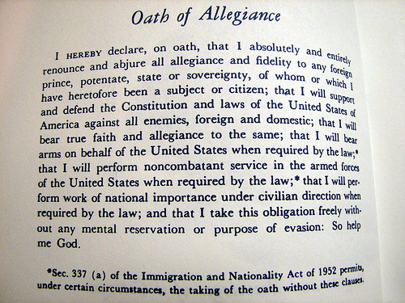

The American's Creed:
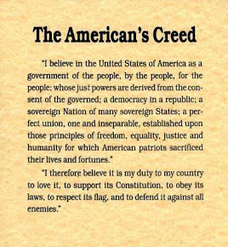
Preamble to the Constitution:
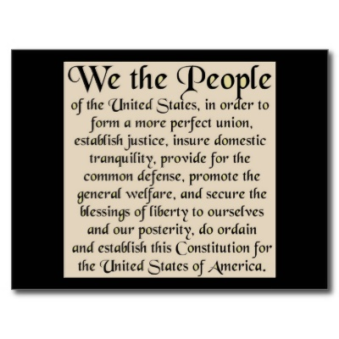
The Inscription on the Statue of Liberty:
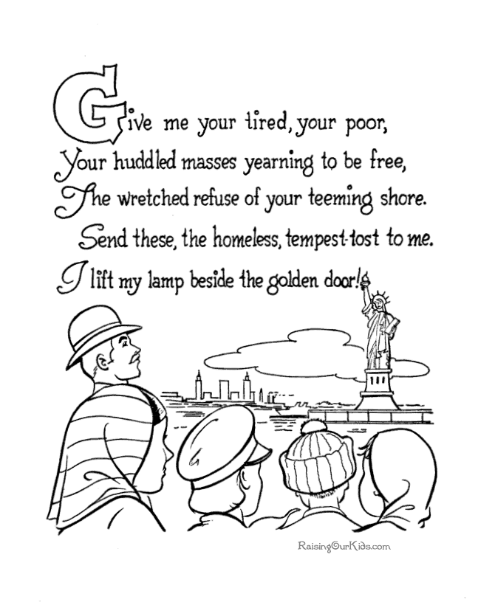

The Pledge of Allegiance
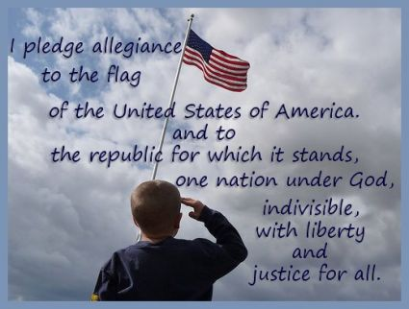

The Declaration of Independence:
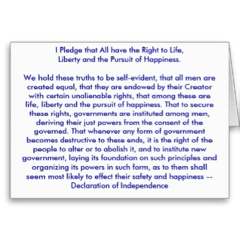

Please let me know if you have any questions.

